Performance Test Report

Manufacturer |  | H&abyz Co., Ltd.
Product name |  | Digital X-ray Imaging System
Model Name |  | HnX-R1
Ref no. | (G series) | G1417CW, G1417CWP, G1417FW, G1417FWP,  G1717CW, G1717CWP, G1717FW, G1717FWP
 | (2/3G series) | A1717MCW, A1417MCW, F1417MCW
 | Console software | HnVUE

 | Write | Review | Approval
Name | Han, Jimin | Kim, Myeongseop | Hur, Namkyu
Dept. | R&D Team | R&D Team Leader | Quality Management Representative
Date | 2025.07.18 | 2025.07.18 | 2025.07.18
Signature |  |  | 
.

목 차
0. 제·개정이력Revision History 3
1. 개요 Document Overview 4
2. 시험 정보Device information 4
2.1 시험품목 4
2.2 시험환경 4
3. Test data 요약 5
4. Test contents 시험 내용 6
4.1 의료용 영상의 획득, 저장, 전송 등의 기능 6
4.2 촬영된 환자의 신상정보, 촬영 오더 정보, 촬영 영상 등의 저장, 조회 7
4.3 영상의 확대, 축소, 회전, 이동, 밝기 조절 등의 영상 조작 8
4.4 영상의 레이아웃 표시 선택, Thumbnail 영상포시, 부분 확대 등의 기능 8
4.5 DICOM 3.0규격지원 영상 포맷 및 전송, 저장기능 9
4.6 사용 권한을 부여받은 사용자 ID 10
4.7 영상삭제 권한 승인 10
4.8 PACS 서버 오류 시 해결방법 제공 11
4.9 오류 발생 시 안내 메시지 12
4.10 촬영된 영상의 환자정보 확인 12
4.11 PACS와 통신 연결 13
5. 결론 14
6. 기타 첨부서류 14

- Revision History
Rev. No. | Issue date | Note
0 | 2025.07.18 | First establishment

- Document Overview
This test report is a test report to confirm the performance of the Console software(HnVUE) of the Digital X-ray Imaging System (HnX-R1).

- Device information

Test item
- Product name: Digital X-ray Imaging System
- Model name: HnX-R1
- Test product: HnVUE
Console Software | Ref no. | Version
 | HnVUE | 1.0.0.37

Test environment
- Test date: 2025.07.14~2025.07.18
- Test site: H&abyz Co., Ltd. (2-dong, 41-16 Cheoinseong-ro, Namsa-myeon, Cheoin-gu, Yongin-si Gyeonggi-do, Korea Rep.)

- Summary of Test Results
No | Test item | Test criteria | Test method | Test result
1 | Performance | Capable of acquiring, storing, and transmitting medical images. | Verify the acquisition, storage, and transmission functions of medical images. | PASS
2 | Performance | Storage and retrieval of patient information, imaging order information, and captured images are possible. | Check each piece of information in the captured images. | PASS
3 | Performance | Image manipulations include zooming in and out, rotating, moving, and adjusting brightness. | Check each operation in the captured images. | PASS
4 | Performance | Functions include selecting image layouts, displaying thumbnails, and partial magnification. | Check each function in the captured images. | PASS
5 | Performance | DICOM 3.0 standard-compliant image formats and transmission and storage capabilities are available. | 1. Click Close Study or Send to confirm DICOM transmission by checking the blue light in the PACS status window. 2. Click Print to confirm DICOM printing. | PASS
6 | Security | Logging in with an authorized user ID is required to operate the imaging software, and data and information are protected against unauthorized access by anyone other than authorized users. | When using the Console software, ensure that access is only possible with the assigned user ID. | PASS
7 | Security | Image deletion is performed after an authorization process to prevent accidental or intentional deletion. | Verify that the authorization process is in place when deleting images. | PASS
8 | Security | Procedures and solutions are provided when the PACS server is down and image transmission is impossible. | Verify that PACS server downtime handling and resolution methods are provided. | PASS
9 | Security | In the event of a hardware or software error, an on-screen notification message is provided. | Verify that on-screen guidance messages are provided in the event of hardware or software errors. | PASS
10 | Security | Patient information from captured images can be viewed. | Verify patient information in captured images. | PASS
11 | Security | The device can be used through a communication connection with the PACS. | Verify the connection between the PACS and the detector. | PASS

- Test contents

Functions for acquiring, storing, and transmitting medical images
No. | Test items | Test criteria | Test method | Test result
1 | Performance | Capable of acquiring, storing, and transmitting medical images. | Check the capabilities of acquiring, storing, and transmitting medical images. | PASS
* Test data
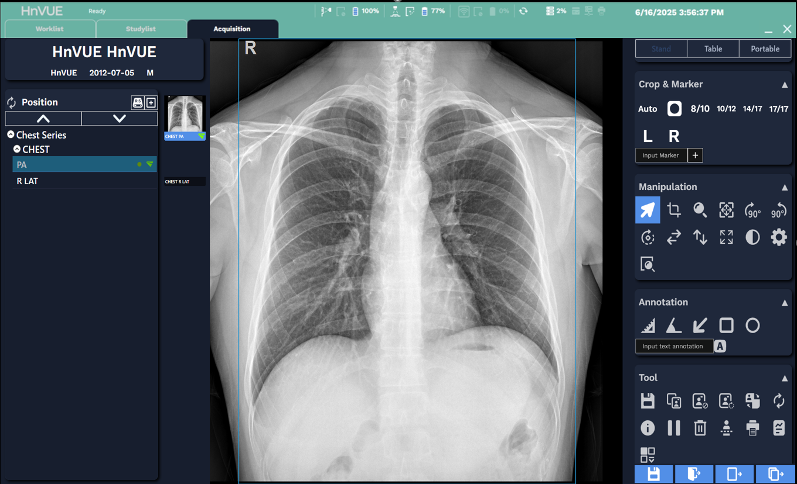 | 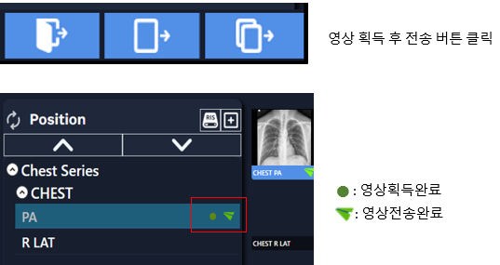

Storage and retrieval of patient personal information, shooting order information, and shooting videos
No. | Test items | Test criteria | Test method | Test result
2 | Performance | Patient information, imaging order information, and captured images can be stored and retrieved. | Check each piece of information in the captured images. | PASS
* Test data
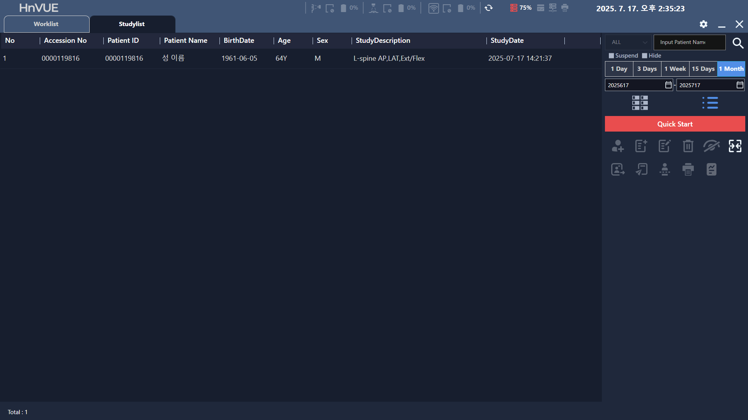 | 

Image manipulation such as zooming in, out, rotating, moving, and adjusting the brightness of the image
No. | Test items | Test criteria | Test method | Test result
3 | Performance | Video manipulations such as zooming in, zooming out, rotating, moving, and adjusting brightness are possible. | Check each manipulation of the captured video. | PASS

* Test data
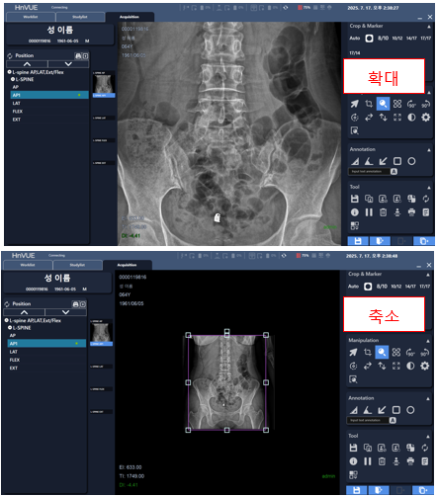 | 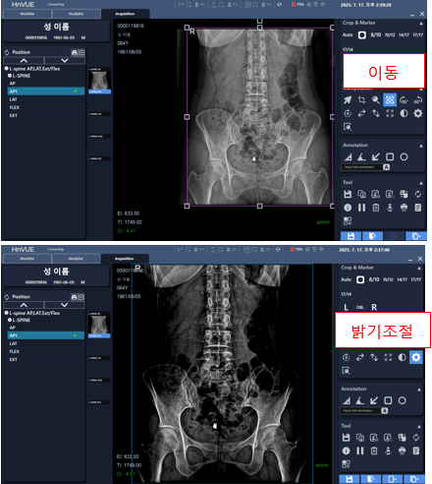

Features such as selecting the layout of the video, displaying thumbnails, and zooming in on a part of the video
No. | Test items | Test criteria | Test method | Test result
4 | Performance | Features include selecting the video layout, thumbnail display, and partial zoom. | Check each feature of the captured video. | PASS

* Test data
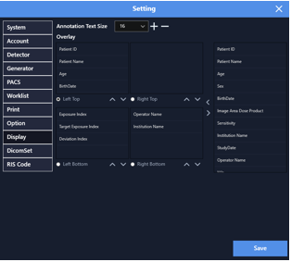 | 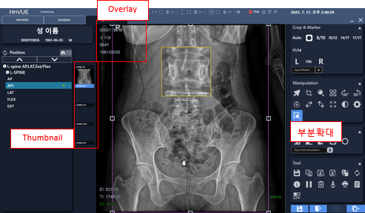

DICOM 3.0 standard support image formats and transmission and storage functions
No. | Test items | Test criteria | Test method | Test result
5 | Performance | DICOM 3.0 standard-compliant image formats, transmission, and storage capabilities are available. | 1. Click Close Study or Send to confirm DICOM transmission by checking the blue light in the PACS status window.  2. Click Print to confirm DICOM printing. | PASS

* Test data
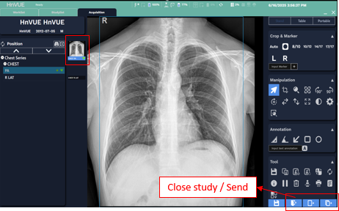 | 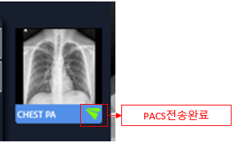

User ID granted permission
No. | Test items | Test criteria | Test method | Test result
6 | Security | To operate the video software, you must log in with an authorized user ID. Information and data are protected, preventing access by anyone other than authorized users. | When using the console software, ensure that access is restricted to authorized user IDs. | PASS

* Test data
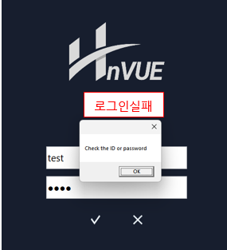 | 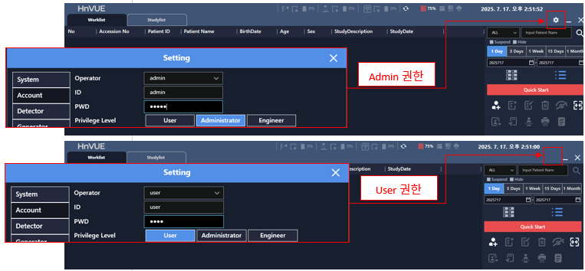

Approval of video deletion permission
No. | Test items | Test criteria | Test method | Test result
7 | Security | To prevent accidental or intentional deletion of videos, deletions are processed through a permission approval process. | Verify that the approval process is running when deleting a video. | PASS
* Test data
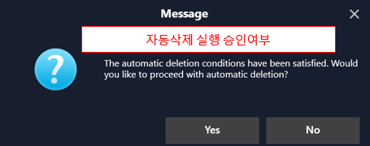 | 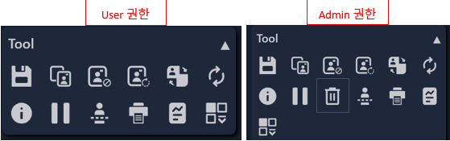

Provides solutions for PACS server errors
No. | Test items | Test criteria | Test method | Test result
8 | Security | Provides solutions and troubleshooting methods when the PACS server is down and image transmission is impossible. | Check if solutions and troubleshooting methods are available when the PACS server is down. | PASS

* Test data
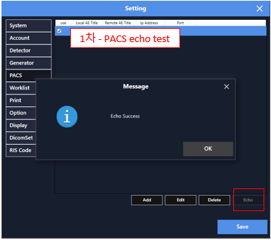 | 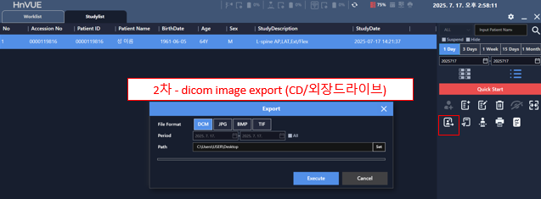

Guidance message when an error occurs
No. | Test items | Test criteria | Test method | Test result
9 | Security | If a hardware or software error occurs, a notification message is displayed on the screen. | Check whether a notification message is displayed on the screen when a hardware or software error occurs. | PASS

* Test data
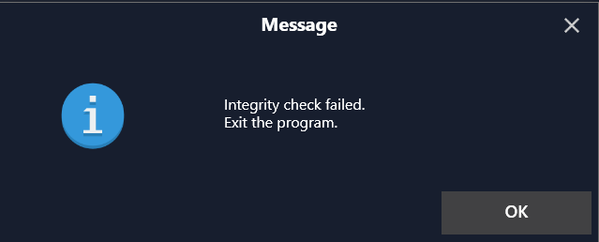

Confirming patient information in recorded images
No. | Test items | Test criteria | Test method | Test result
10 | Security | You can check patient information from the recorded images. | Check patient information from the recorded images. | PASS

* Test data


Communication with PACS
No. | Test items | Test criteria | Test method | Test result
11 | Security | The device can be used through a communication connection with the PACS. | Check the connection between the PACS and the detector. | PASS

* Test data
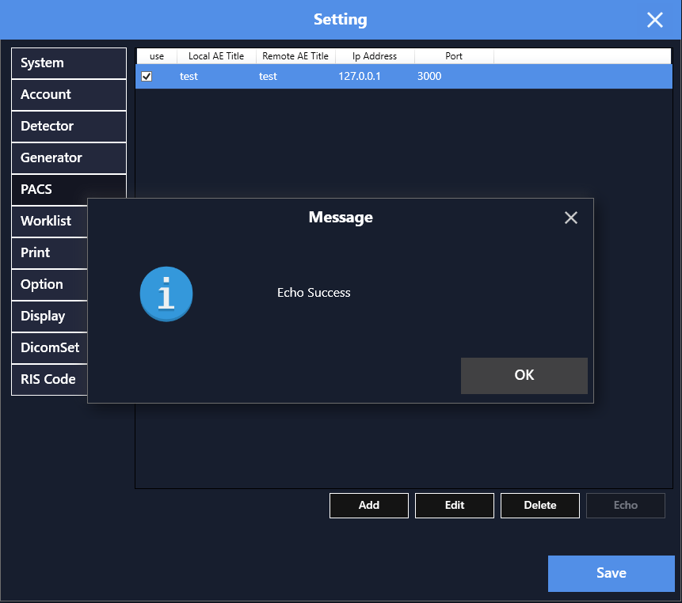

- Conclusion
The test data confirmed that the medical imaging device (model name: HnX-R1, HnVUE) performed without any issues.

- Other Attachments
[Attachment 1.] ISO 13485 Certificate

[Attachment 1.] ISO 13485 Certificate


